ASSESSING THE PERFORMANCE OF STUDENT BY EMOTIONS USING MACHINE LEARNING AND DEEP LEARNING TECHNIQUES

An Industry Oriented Mini Project submitted in partial fulfilment of requirements for the award of degree of

Bachelor of Technology
In
Information Technology

By
D. MANASWINI (Reg No: 16131A1261)
N. SAI SRUTHI (Reg No: 16131A1276)
V. KAVYA (Reg No: 16131A12A7)
V. A. SRIKAR (Reg No: 16131A12B2)



Under the esteemed
guidance of

DR. D.UMA DEVI
(Associate professor)

Department of Information Technology

GAYATRI VIDYA PARISHAD COLLEGE OF ENGINEERING(AUTONOMOUS)

(Affiliated to JNTU-K, Kakinada)
VISAKHAPATNAM
2019 - 2020

Gayatri Vidya Parishad College of Engineering (Autonomous)
Visakhapatnam



CERTIFICATE

This report “ASSESSING THE PERFORMANCE OF STUDENT BY EMOTIONS USING MACHINE LEARNING AND DEEP LEARNING TECHNIQUES” is a bonafide record of the
mini project work submitted

By

D. MANASWINI (Reg No: 16131A1261)
N. SAI SRUTHI (Reg No: 16131A1276)
V. KAVYA (Reg No: 16131A12A7)
V. A. SRIKAR (Reg No: 16131A12B2)

in their VII semester in partial fulfilment of the requirements for the Award of Degree of
Bachelor of Technology
In
Information Technology
During the academic year 2019-2020

DR. D. UMA DEVI DR. K. B. MADHURI

Project Guides Head of the Department

DECLARATION

We here by declare that this industry oriented mini project entitled “ASSESSING THE
PERFORMANCE OF STUDENT BY EMOTIONS USING MACHINE LEARNING AND DEEP LEARNING TECHNIQUES” is a bonafide work done by us and submitted to Department of Information Technology, G.V.P College of Engineering (Autonomous),Visakhapatnam, in partial fulfilment for the award of the degree of B.Tech is of our own and it is not submitted to any other university or has been published any time before.

PLACE: Visakhapatnam D. MANASWINI (16131A1261)
DATE: N. SAI SRUTHI (16131A1276)
V. KAVYA (16131A12A7)
V. A. SRIKAR (16131A12B2)

ACKNOWLEDGEMENT
We would like to express our deep sense of gratitude to our esteemed institute Gayatri Vidya
Parishad College of Engineering (Autonomous)‖, which has provided us an opportunity to fulfil our cherished desire.

We express our sincere thanks to our Principal Prof. A. B. KOTESWARARAO for his encouragement to us during the course of this project, giving us a chance to explore and learn new technologies in the form of mini project.

We express our deep sense of Gratitude to Prof. K. B. MADHURI, Head of the Department, Department of Information Technology.

We express our profound gratitude and our deep indebtedness to our guide DR. D. Uma Devi, Associate Professor whose valuable suggestions, guidance and comprehensive assistance helped us a lot in realizing our present project.

We also thank Mr. D. NAGA TEJ, Assistant Professor project coordinator, for guiding us throughout the project and lead us in completing our project efficiently.

We would also like to thank all the members of teaching and non-teaching staff of the Information Technology Department for all their support in completion of our project.

Project Members:

D. MANASWINI (16131A1261)
N. SAI SRUTHI (16131A1276)
V. KAVYA (16131A12A7)
V. A. SRIKAR (16131A12B2)

ABSTRACT

In the present day scenario, Assessment of educational skills independently is prominently required which can be done by the techniques of Deep Learning. The main objective of the project is to evaluate the performance of the student while coding using his facial expressions. This model initially captures the facial expressions of the student using a camera which is our data set. These inputs are fed into the deep learning classification algorithms to assess the behavior of the student and then those outputs are fed into the machine learning algorithms to assess his performance.This project replaces external evaluation in many of the educational institutions. This model summarizes the successful patterns of a student by avoiding the pitfalls of average student patterns to develop an innovative analysis tool and promotes to develop the best education.

CONTENTS
- Introduction …………………………………………………………………………………….01
  - Objective
  - About the project
  - Procedure and Purpose
- Analysis…………………………………………………………………………………………..03
  - Existing System
  - Proposed System

3. Software Requirements Specification………………………………………………………….05
3.1 Functional requirements
3.2 Non-Functional requirements
3.3 System requirements
3.3.1 Software requirements
3.3.2 Hardware requirements
3.4 Feasibility study
3.4.1 Technical feasibility
3.4.2 Operational feasibility
3.4.3 Economic feasibility
- SYSTEM DESIGN……………………………………………………………………………….10
  - Design principles
  - Block diagram
  - Introduction to UML
  - Building blocks of UML
  - UML Diagrams
  - CNN (Convolutional Neural Networks)
  - KNN (k-Nearest Neighbour)
- Development……………………………………………………………………………………...27
  - Input Dataset
  - Source Code and Outputs

- Testing .……………………………………………...……………………………………………51
  - Introduction
  - Testing objectives
  - Testing principles
  - Types of testing
- Conclusion…………………………..……………………………………………………………56
- Bibliography…………………………………………………………………………….……….57

1.INTRODUCTION

Ongoing studies in the field of software industry and development have shown that emotions result in determining the productivity of programmers. In the field of effective computing, many techniques and tools to recognize the emotions of students were proposed. However, those have not been verified yet and stood effective to monitor the behaviour of students.Inculcating such techniques in the educational institutions might reduce the evaluation complexity and this can help students in staying productive as well as to capture the emotions like frustration which reduce their performance. Therefore,these tools are essential to get into picture to evaluate and assess the behaviour of students while coding.

1.1 OBJECTIVE
- Analyse the behaviour of a student based on the emotions collected while they were solving coding questions.
- Assess the performance of the students based on the behaviour.
- Provide a classification of students who are successful and not successful in getting the output.

1.2 ABOUT THE PROJECT
Our project is to utilize computer vision and deep-learning tools for predicting the behaviour of a student while solving coding questions.
The dataset is organized into 3 folders (train, test, validation) and contains subfolders for each folder. There are thousands of images of students while programming (JPEG) and 7 categories of emotions such as
- Happy
- Sad
- Angry
- Disgust
- Fear
- Neutral
- Surprise

1.3 PROCEDURE AND PURPOSE
A web-camera which is placed with student’s computer will capture the video of the student while he/she is solving the coding problem.The captured video will be divided into desired number of frames,passing these frames to the deep-learning techniques we get the emotion of each frame and the count.All the frame counts of various students are kept is a comma separated value file which acts as the emerging dataset to assess the performance of the student.A binary classification algorithm is applied on the new data set and predict that the particular student has got the output or not.

The purpose of our project is to reduce the evaluation complexity and eliminate the external evaluation and exist as an effective tool in the present day educational institutions.

2.ANALYSIS

2.1 EXISTING SYSTEM
- There are various manual methods to analyse the student emotions while solving coding problems. Face-to-Face interaction with each student, where the mentor comes and check how the student is actually feeling for solving the coding question.
- We can also produce feedback forms to the students to know the emotion towards the exam.However these didn’t prove to be successful.
DRAWBACKS OF EXISTING SYSTEM:
- Chances of Malpracticing
- External Evaluation
- Complexity of work
- Time consuming



2.2 PROPOSED SYSTEM
To overcome the drawbacks of the existing system, the proposed system has been evolved.
- Using Computer vision and Image-Based Deep Learning techniques we are able to create an analysis tool for analysing emotions exhibited by students while solving coding problems, which is helpful in analysing the behaviour and assessing the performance of the student.

- Deep learning classification techniques can be used to classify the student’s emotions into different categories.Based on these emotions,we can predict the student’s success using machine learning classification algorithms.

ADVANTAGES OF PROPOSED SYSTEM:
- Easy to analyse.
- Less time consuming and easy to control.
- External evaluation can be reduced.
- Easy to identify the below average performing students.
- Can prevent malpractices.

3.SOFTWARE REQUIRMENTS SPECIFICATION

SRS is a document created by system analyst after the requirements are collected from various stakeholders. SRS defines how the intended software will Interact with hardware, external interfaces, speed of operation, response time of system, portability of software across various platforms, maintainability, speed of recovery after crashing, Security, Quality, Limitations etc. The requirements received from client are written in natural language. It is the responsibility of system analyst to document the requirements in technical language so that they can be comprehended and useful by the software development team. The introduction of the software requirement specification states the goals and objectives of the software, describing it in the context of the computer-base system. The SRS includes an information description, functional description, behavioural description, validation criteria.
SRS should come up with following features:
- User Requirements are expressed in natural language.
- Technical requirements are expressed in structured language, which is used inside the organization.
- Design description should be written in Pseudocode.
- Format of Forms and GUI screen-prints.
- Conditional and mathematical notations for DFDs etc.
The purpose of this document is to present the software requirements in a precise and easily understood manner. This document provides the functional, performance, design and verification requirements of the software to be developed. After requirement specifications are developed, the requirements mentioned in this document are validated. User might ask for illegal, impractical solution or experts may interpret the requirements incorrectly. This results in huge increase in cost if not nipped in the bud.
Requirements can be checked against following conditions –
- If they can be practically implemented.
- If they are valid and as per functionality and domain of software.
- If there are any ambiguities.
- If they are complete.
- If they can be demonstrated.
A requirement is a statement about what the proposed system will do that all Stakeholders agree must be made true in order for the customer’s problem to be adequately solved. Requirements can be divided into two major types, functional and non-functional. Domain analysis, or product line analysis, is the process of analysing related software systems in a domain to find their common and variable parts. It is a model of wider business context for the system. To perform domain analysis, you must gather information from whatever sources of Information are available: these include the domain experts and any books about the domain, any existing software and its documentation, and any other documents you can find.

3.1 FUNCTIONAL REQUIRMENTS
A functional requirement defines a function of a system or it’s component. A function can be described as set of inputs, the behaviour and outputs. It also depends upon the type of software, expected users and the type of system where the software is used.
Functional user requirements may be high-level statements of what the system should do but functional system requirements should also describe clearly about the system services in detail.
The functional requirements in our project are:
- To predict the behaviour of the student while solving coding problems.
- To assess the performance of the student whether he has got output or not.
- To identify malpracticing during the coding examinations.

3.2 NON-FUNCTIONAL REQUIREMENTS
A non- functional requirement is a requirement that specify criteria that can be used to judge the operation of a system, rather than specific behaviours. Non-functional requirements are called qualities of a system, there are as follows:
- Performance

  - Accuracy
(The correctness in the trained model in learning and classifying).
Our model is trained successfully with an accuracy of 96% against custom data set.
  - Processing time
(How long is acceptable to perform key functions are export/import data?).
Our model takes fraction of seconds to process the data.

- Capacity and scalability

  - Storage
(How much data are we going to need to achieve what we need)?
Our model is trained with couple of gigabytes of data.

- Recovery
  - Restore time
(How long it should take to get back up and running?)
It takes around 2 hours to get back up and run the entire model.
  - Backup time
(How long does it take to back your data?)
It takes around 2 hours to get back the data.

3.3 SYSTEM REQUIREMENTS
System requirements are nothing but Software requirements and Hardware requirements.

3.3.1 SOFTWARE REQUIREMENTS
- Operating system : WINDOWS/LINUX(PREFERABLY)
- Programming languages :Python
- Backend : Keras, Tensor flow
- Editor : Pycharm or jupyter notebook
- Packages : numpy,pandas,matplotlib,shutil,cv2

3.3.2 HARDWARE REQIUREMENTS

A laptop with the following requirements:
- Processor: Intel i5 or higher
- RAM: 4GB or higher
- Disk space: 1TB
- Supported Web-camera

3.4 FEASIBILITY STUDY
Preliminary investigation examines project feasibility; the likelihood the system will be useful to the organization. The main objective of the feasibility study is to test the Technical operational and Economical feasibility for adding new modules and debugging old running system. All systems are feasible if they are given unlimited resources and infinite time. There are aspects in the feasibility study portion of the preliminary investigation.
- Technical Feasibility
- Operational Feasibility
- Economic Feasibility

3.4.1 TECHNICAL FEASIBILITY
Technical feasibility assesses the current resources (such as hardware and software) and technology, which are required to accomplish user requirements in the software within the allocated time and budget. For this, the software development team ascertains whether the current resources and technology can be upgraded or added in the software to accomplish specified user requirements.
Technical feasibility also performs the following tasks.
- Analyses the technical skills and capabilities of the software development team members.
- Determines whether the relevant technology is stable and established.
- Ascertains that the technology chosen for software development has a large number of users so that they can be consulted when problems arise or improvements are required.
The resources we used in our project are:
- OpenCV:

Visual information is the most important type of information perceived, processed and interpreted by the human brain. Image processing is a method to perform some operations on an image, in order to extract some useful information from it.
In our project, OpenCV has been used to record the video while solving coding
problems and to convert the recorded video into frames which will be provided
to the model for training.
It is also used in converting the image from RGB to gray scale and preprocess it.
- Keras:
This is the model used in our project for training, testing and validating the images.

3.4.2 OPERATIONAL FEASIBILITY
Operational feasibility assesses the extent to which the required software performs a series of steps to solve business problems and user requirements. This feasibility is dependent on human resources (software development team) and involves visualizing whether the software will operate after it is developed and be operative once it is installed.
In our project, There is no need of human resources.

3.4.3 ECONOMIC FEASIBILITY
Economic feasibility determines whether the required software is capable of generating financial gains for an organization. It involves the cost incurred on the software development team, estimated cost of hardware and software, cost of performing feasibility study, and so on. For this, it is essential to consider expenses made on purchases (such as hardware purchase) and activities required to carry out software development. In addition, it is necessary to consider the benefits that can be achieved by developing the software.
Software is said to be economically feasible if it focuses on the issues listed below.
- Cost incurred on software development to produce long-term gains for an organization.
- Cost required conducting full software investigation (such as requirements elicitation and requirements analysis).
- Cost of hardware, software, development team, and training

Our project is economically feasible, Until the processor and packages support in any domain.

4.SYSTEM DESIGN

In the context of software, design is a problem solving process whose objective is to find and describe a way to implement the system’s functional requirements while respecting the constraints imposed by the non-functional requirements (including the budget and deadlines) and by adhering to general principles of good quality. Software design is the process of planning a new system to replace or complement an existing system. It is an iterative process through which requirements are translated into the software. During this stage, analyst works with the user to develop a physical model of the system. Software design is an interactive process through which the requirements are translated into a “blue print” for constructing the software.

4.1 DESIGN PRINCIPLES
Software design is both a process and a model. The design process is a set of iterative steps that enable the designer to describe all aspects of the software to be built. Basic design principles enable the software engineer to navigate the design process.
Some of the design principles are:
- The design should be traceable.
- The design should be reviewed to minimize conceptual (semantic) errors.
- The design should not reinvent the wheel. • The design should “minimize the intellectual distance” between the software and the problem as it exists in the real world.
- The design should be assessed for quality as it is being created, not after the fact.

4.2 BLOCK DIAGRAM
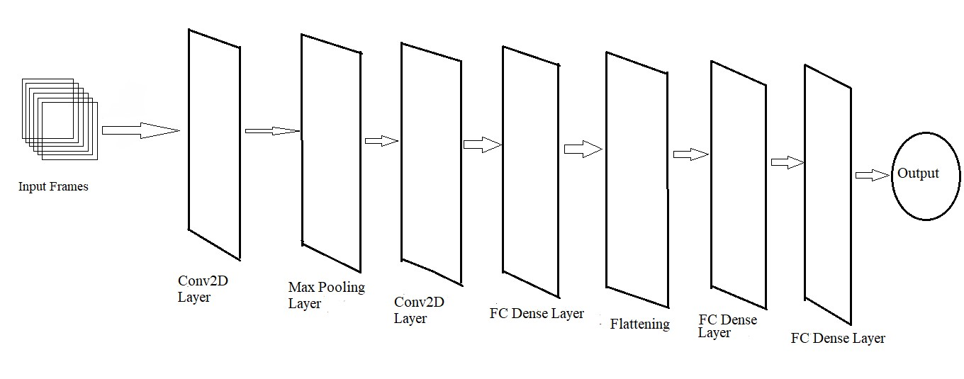

4.3 INTRODUCTION TO UML
The system to be developed is best designed using UML (Unified Modelling Language). The Unified Modelling Language includes a set of graphics notation techniques to create visual models of object-oriented intensive systems. UML is a visual language for specifying, constructing, and documenting the artifacts of software- intensive systems.
Object-Oriented Modelling:
In software, there are several ways to approach a model. The two most common ways are from an algorithmic perspective and from an object-oriented perspective. The traditional view of software development takes an algorithmic perspective. In this approach, the main building block of all software is the procedure or function.
The contemporary view of software development takes an object-oriented perspective.
In this approach, the main building block of all software systems is the object or class.

A Conceptual Model of the UML:
To understand the UML, we need to form a conceptual model of the language, and this requires learning three major elements: the UML's basic building blocks, the rules that dictate how those building blocks may be put together, and some common mechanisms that apply throughout the UML.
4.4 BUILDING BLOCKS OF UML:
The vocabulary of the UML encompasses three kinds of building blocks:
- Things
- Relationships
- Diagrams
Things are the abstractions that are first-class citizens in a model; relationships tie these things together; diagrams group interesting collections of things.
Things in the UML:
There are four kinds of things in the UML:
- Structural things
- Behavioural things
- Grouping things
- Annotational things

4.5 UML Diagrams
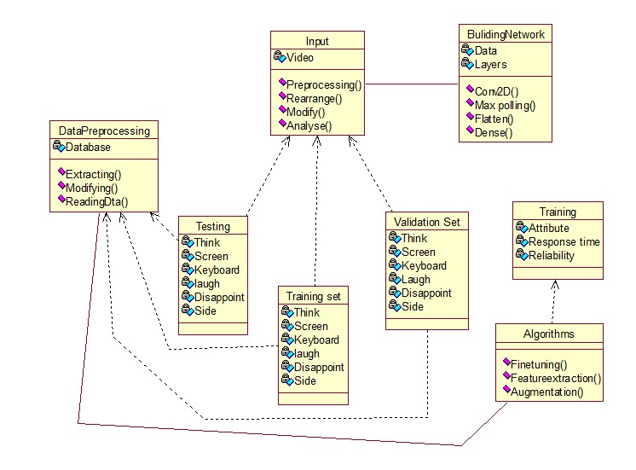

Class Diagram
The total scenario has to be divided into various classes as shown in the above figure.
Keras is basically a backend for the image classification when we want to employ spyder IDE(python) which comes with many packages. Data has to be divided into training,validation and testing sets and data preprocessing is done. Network has to be built which consist of many layers like Conv2D layer,Flatten layer,Dense layer,Max Pooling layer. The model has to be tested with random images picked from dataset and if the accuracy is not good, then some traditional algorithms like Augmentation, Feature Extraction has to be employed.

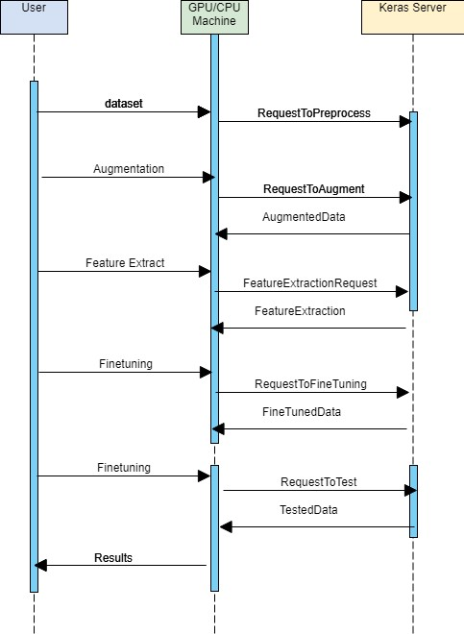
Sequence Diagram

In the above Activity diagram, the data set from the user is passed on to the machine for preprocessing. The machine efficiently interacts with the Server inorder to perform the operations at every stage. Once the layers are built , the training can be started insearch of good accuracies. Improving accuracies can be done by using traditional methods like augmentation,feature extraction and fine tuning. Once good accuracy is seen, we can terminate the training process.

4.6 CNN(Convolutional Neural Network ):

In neural network, Convolutional neural network (ConvNets or CNNs) is one of the main categories to do images recognition, images classifications. Objects detections, recognition of faces etc, are some of areas where CNNs are widely used.
CNN image classification takes an input i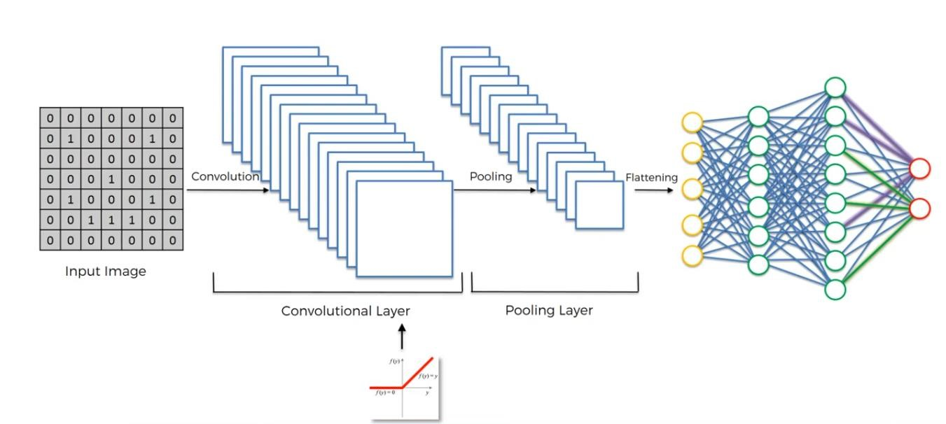mage, process it and classify it under certain categories. Computer looks an input image as array of pixels and it depends on the image resolution
The most important layers in CNN are:
- Convolution Layer
- Polling Layer
- Flattening
- Full Connection

Convolutional Neural Network:

Example of CNN:

STEP 1: Convolution Layer
Convolution Layer performs the convolution operation. The three main elements of convolution operation are:
- Input image
- Feature Map
- Feature Detector

The Convolution Operation:
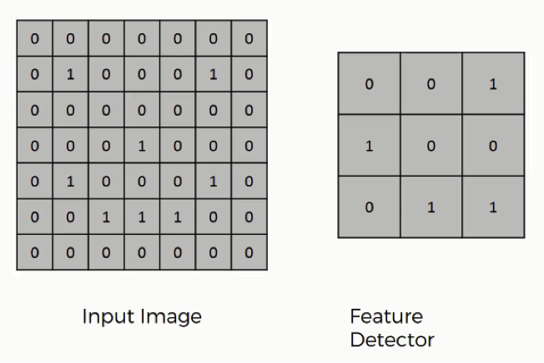

Working of Convolution Operation:

- Place the Feature detector on the top-left corner of the input image within the borders.
count the number of cells in which the feature detector matches the input image.
- The number of matching cells is then inserted in the top-left cell of the feature map.
- Move the feature detector one cell to the right and do the same operation. since we are moving the feature detector one cell at time, that would be called a stride of one pixel.

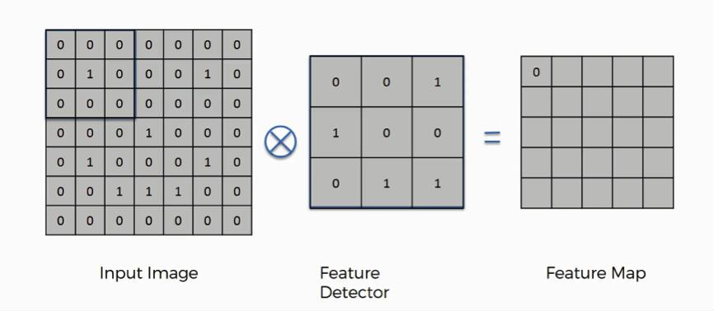

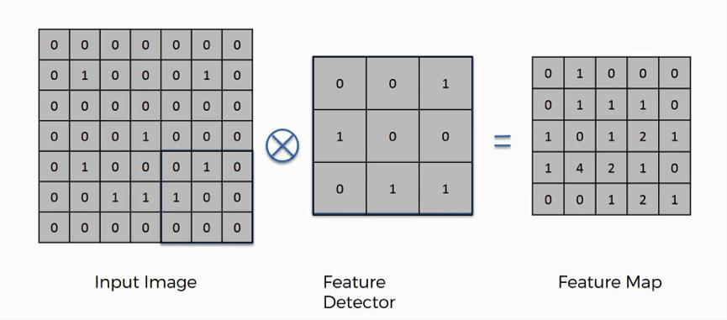
The above example is a very simplified one.In reality, convolutional neural networks develop multiple feature detectors and use them to develop several feature maps which are referred to as convolutional layers.
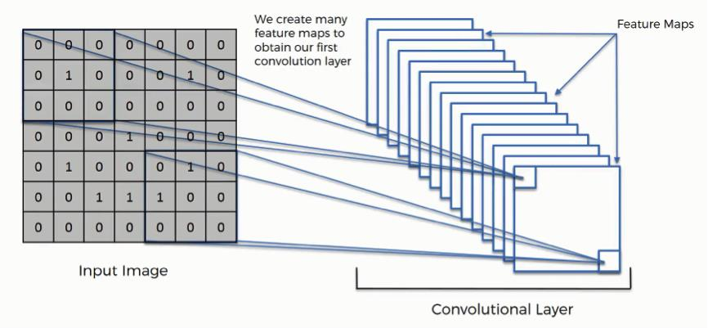

STEP 2: Max Pooling

The purpose of max pooling is enabling the convolutional neural network to detect the object in the image when presented with the image in any manner.

Pooled Feature Map:

The process of filling in a pooled feature map differs from the one we used to come up with the regular feature map.

place a 2×2 box at the top-left corner, and move along the row. For every 4 cells box stands on, then find the maximum numerical value and insert it into the pooled feature map.

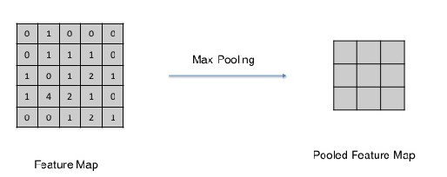

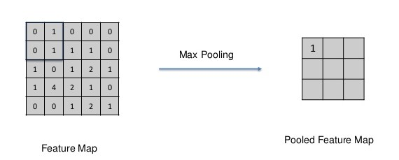

After, performing the same operation for the entire matrix, The Pooled feature map will be formed as shown below.

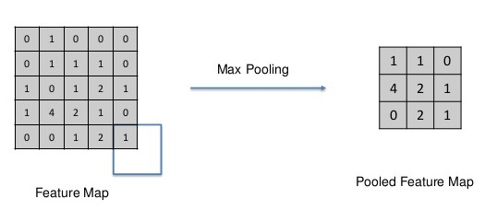

STEP 3 : Flattening

In this Flattening layer, we are supposed to have a pooled feature map by now. we are going to flatten our pooled feature map into a column like in the image below.

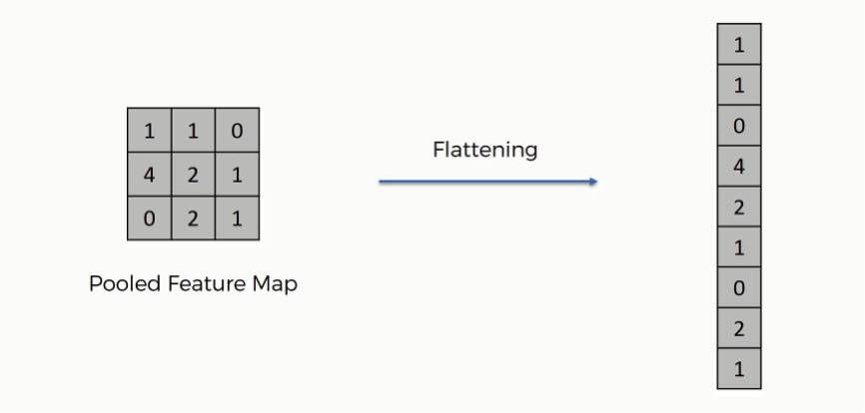

we have multiple pooled feature maps from the previous step.

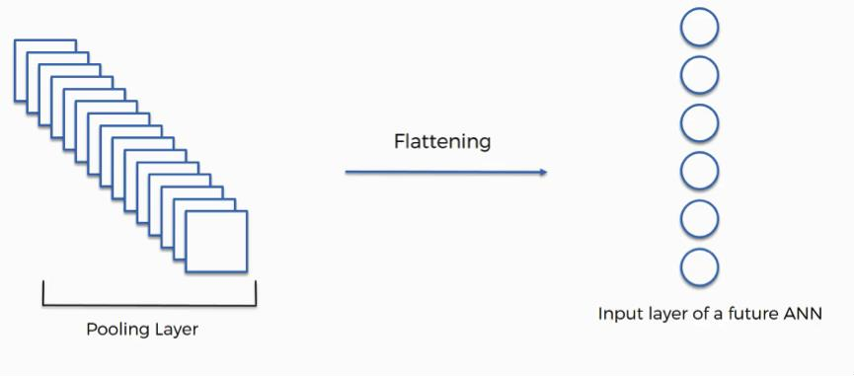

STEP 4: Full Connection

It’s here where the process of creating a convolutional neural network begins to take a more complex and sophisticated turn.

There are three layers in the full connection step:
- Input layer
- Fully-connected layer
- Output layer
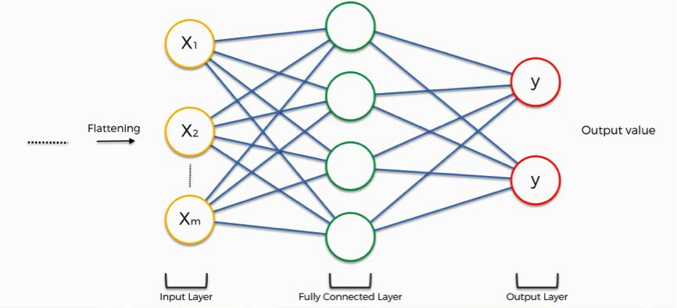

The role of this fully connected layer is to take this data and combine the features into a wider variety of attributes that make the convolutional network more capable of classifying images, which is the whole purpose from creating a convolutional neural network.

4.7 KNN(k-Nearest Neighbour):

Introduction:
In pattern recognition, the k-nearest neighbors algorithm (KNN) is a non-parametric method used for classification and regression. In both cases, the input consists of the k closest training examples in the feature space. The output depends on whether k-NN is used for classification or regression:
- In KNN classification, the output is a class membership. An object is classified by a plurality vote of its neighbours, with the object being assigned to the class most common among its k- nearest neighbours (k is a positive integer, typically small). If k = 1, then the object is simply assigned to the class of that single nearest neighbour.
- In KNN regression, the output is the property value for the object. This value is the average of the values of k nearest neighbours.

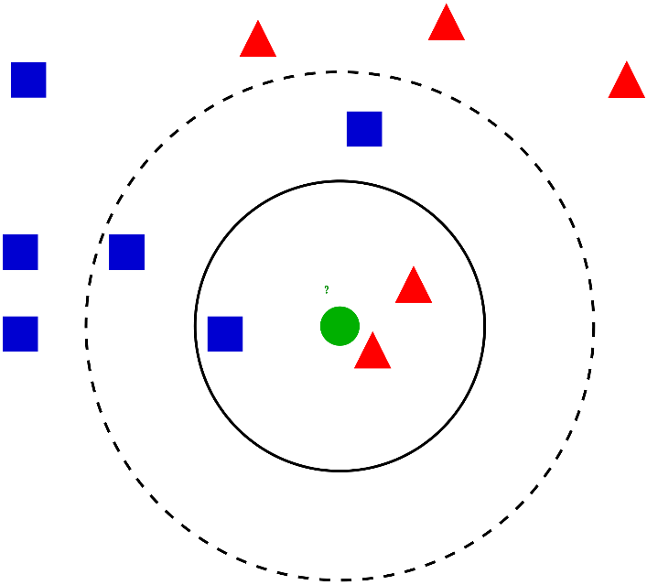
In this article, we will talk about another widely used machine learning classification technique called K-nearest neighbors (KNN) . Our focus will be primarily on how does the algorithm work and how does the input parameter affect the output/prediction.

How does KNN Algorithm work?
Let’s take a simple case to understand this algorithm. Following is a spread of red circles (RC) and green squares (GS) :
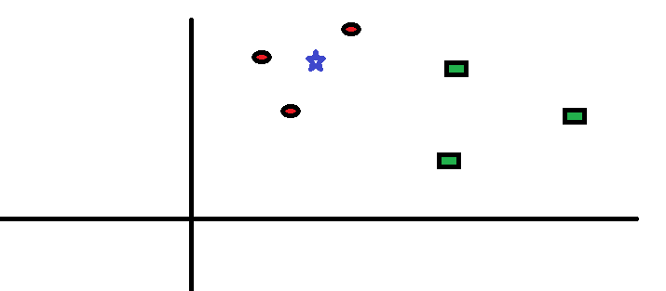
You intend to find out the class of the blue star (BS) . BS can either be RC or GS and nothing else. The “K” is KNN algorithm is the nearest neighbors we wish to take vote from. Let’s say K = 3. Hence, we will now make a circle with BS as center just as big as to enclose only three datapoints on the plane. Refer to following diagram for more details:
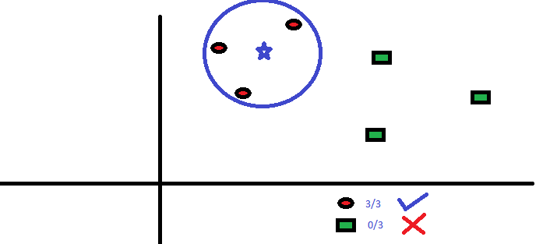
The three closest points to BS is all RC. Hence, with good confidence level we can say that the BS should belong to the class RC. Here, the choice became very obvious as all three votes from the closest neighbor went to RC. The choice of the parameter K is very crucial in this algorithm. Next we will understand what are the factors to be considered to conclude the best K.

How do we choose the k factor?
First let us try to understand what exactly does K influence in the algorithm. If we see the last example, given that all the 6 training observation remain constant, with a given K value we can make boundaries of each class. These boundaries will segregate RC from GS. The same way, let’s try to see the effect 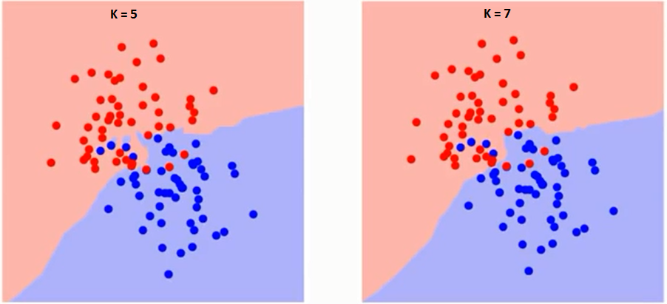of value “K” on the class boundaries. Following are the different boundaries separating the two classes with different values of K.
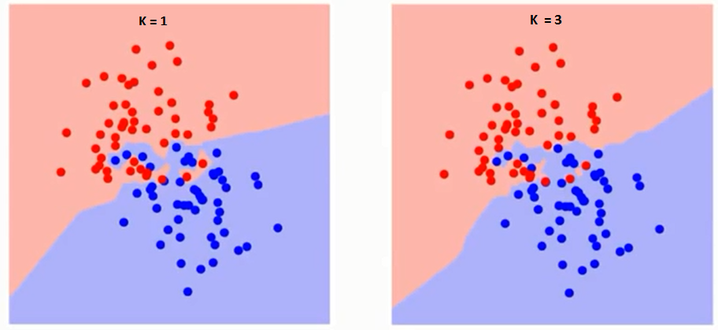

If you watch carefully, you can see that the boundary becomes smoother with increasing value of K. With K increasing to infinity it finally becomes all blue or all red depending on the total majority. The training error rate and the validation error rate are two parameters we need to access on different K-value. Following is the curve for the training error rate with varying value of K :
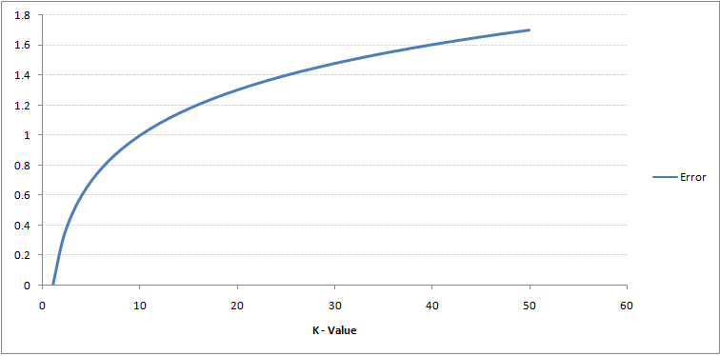
As you can see, the error rate at K=1 is always zero for the training sample. This is because the closest point to any training data point is itself.Hence the prediction is always accurate with K=1. If validation error curve would have been similar, our choice of K would have been 1. Following is the validation error curve with varying value of K:
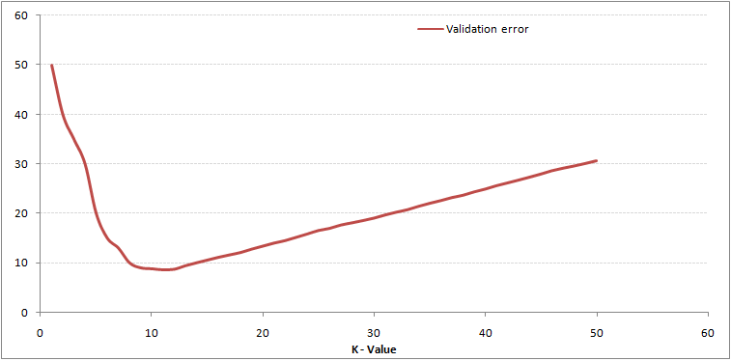This makes the story more clear. At K=1, we were overfitting the boundaries. Hence, error rate initially decreases and reaches a minima. After the minima point, it then increase with increasing K. To get the optimal value of K, you can segregate the training and validation from the initial dataset. Now plot the validation error curve to get the optimal value of K. This value of K should be used for all predictions.

Pseudo code of KNN:
We can implement a KNN model by following the below steps:
- Load the data
- Initialise the value of k
- For getting the predicted class, iterate from 1 to total number of training data points
  - Calculate the distance between test data and each row of training data. Here we will use Euclidean distance as our distance metric since it’s the most popular method. The other metrics that can be used are Chebyshev, cosine, etc.
  - Sort the calculated distances in ascending order based on distance values
  - Get top k rows from the sorted array
  - Get the most frequent class of these rows
  - Return the predicted class

Usage of KNN in our project:
After the emotions are classified,the count of each emotion is loaded in a CSV file,the comma separated value file is used as a dataset to train the and a .pkl model using KNN classification algorithm.
After training,the datasets are classified using binary classification into 2 classes namely:
Executed and Not Executed.
When a new video is captured,the frame count of each emotion is given to the .pkl model to decide whether the student in the particular video has executed the program or not(based on his emotions).

5. DEVELOPMENT

5.1 Input Dataset

Our project is to utilize deep-learning tools for analysing the behaviour of student while solving coding questions and assess the performance of the student using machine learning algorithms
The dataset is organized into 3 folders (train, test, validation) and contains subfolders for each image category. There are thousands images of students while programming (JPEG) and 7 categories like happy,sad,fear,angry,disgust,surprise,neutral.
A web-camera which is situated at the student’s computer will record the video of the student while he/she is solving the coding problem, where some frames from the video are taken to analyse the behaviour of the student. The frames are divided into 6 categories which will be provided as input for training the model. After training, a video will be given to the model to predict the behaviour of the student. After the behaviour is predicted it is stored in a comma separated value file which acts as an emerging data set for determining the performance of the student i.e.,whether he got the output or not.

Dataset Images:

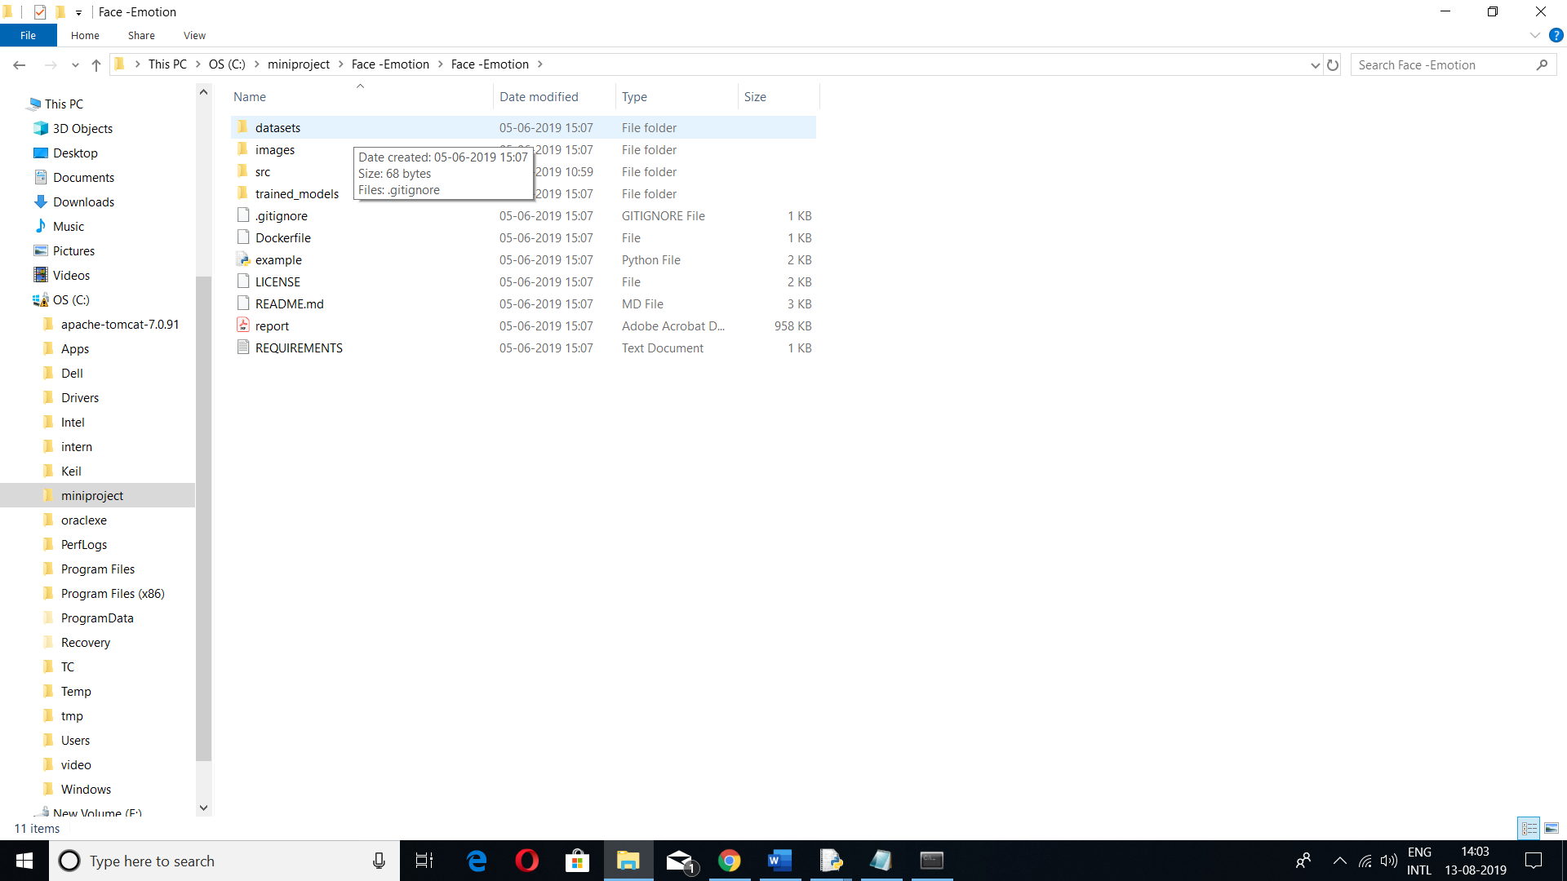
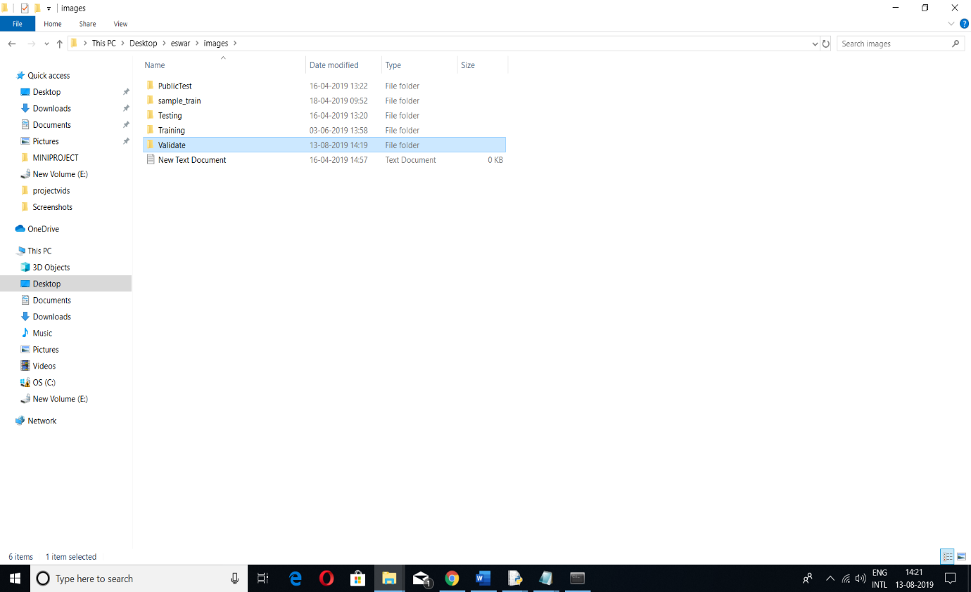

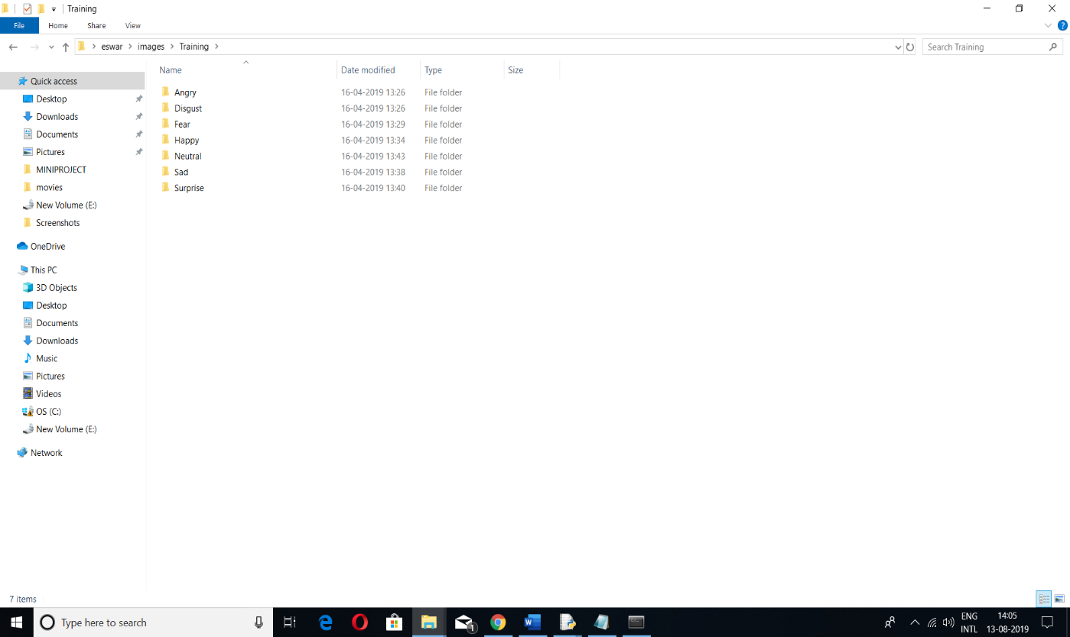
Angry:

This is a negative emotion in which the students express the difficulty in solving the problem.
When the model is trained with these images,if the student is angry,the model automatically predicts it.



Disgust:

This is a negative emotion in which the students express the difficulty in solving the problem.
When the model is trained with these images,if the student is in disgust,the model automatically predicts it.

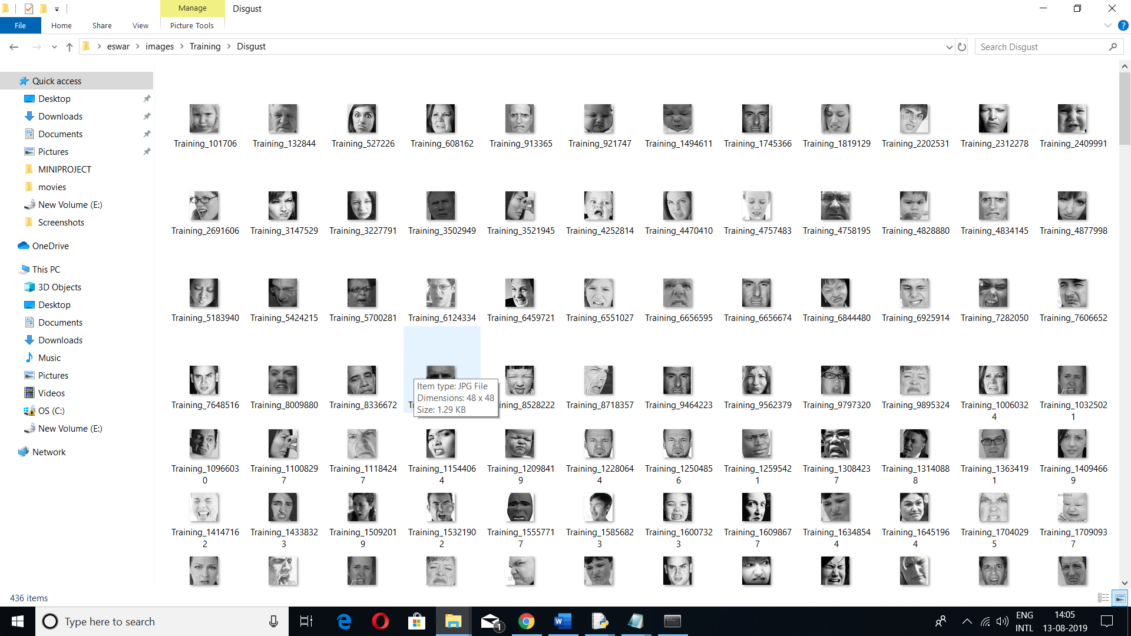

Fear:

This is a negative emotion in which the students express the difficulty in solving the problem.
When the model is trained with these images,if the student is feeling afraid,the model automatically predicts it.



Happy:

This is a positive emotion in which the students express the comfort in solving the problem.
When the model is trained with these images,if the student is happy,the model automatically predicts it.



Neutral:

This is a neutral emotion in which the students express the no feeling in solving the problem.
When the model is trained with these images,if the student is in neutral state,the model automatically predicts it.

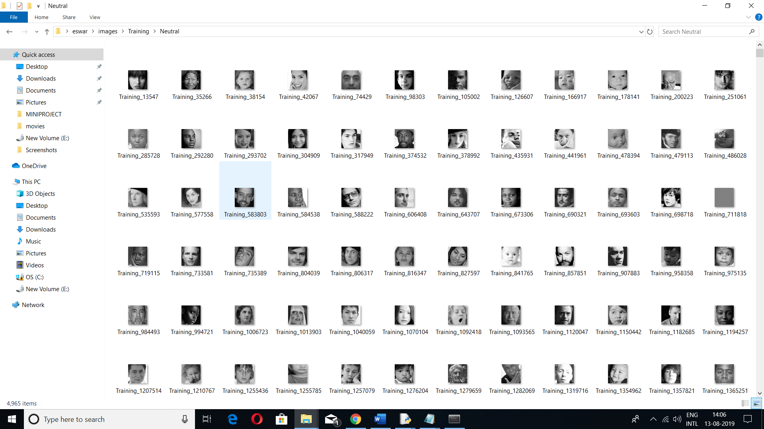

Sad:

This is a negative emotion in which the students express the difficulty in solving the problem.
When the model is trained with these images,if the student is feeling sad, the model automatically predicts it.

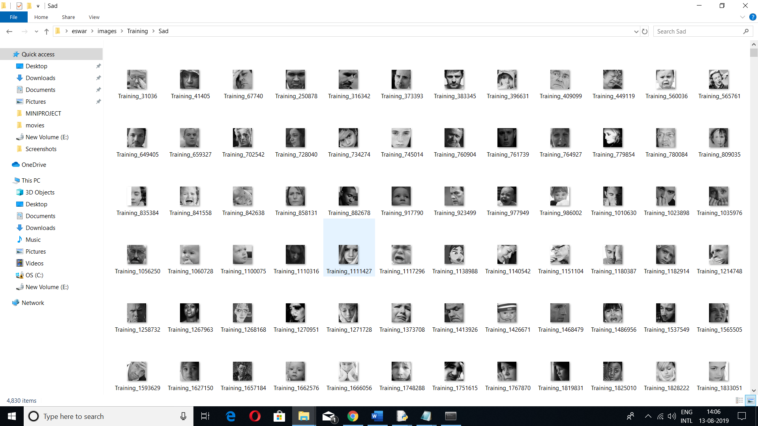

Surprise:

This is a positive emotion in which the students express the enthusiasm in solving the problem.
When the model is trained with these images,if the student is feeling surprised,the model automatically predicts it.

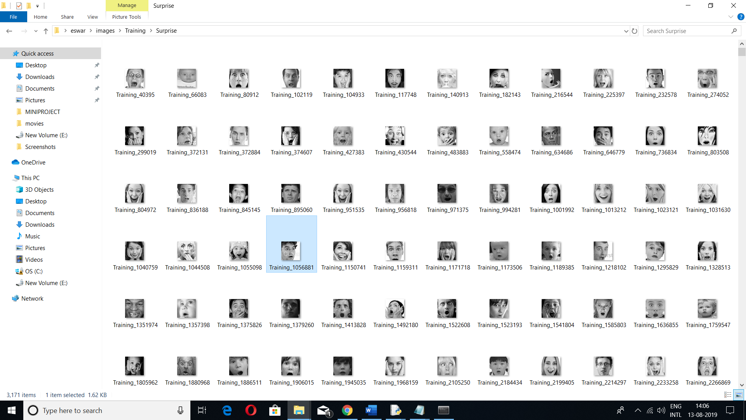

Source Code:

Convolution Neural Networks:

from keras.layers import Activation, Convolution2D, Dropout, Conv2D
from keras.layers import AveragePooling2D, BatchNormalization
from keras.layers import GlobalAveragePooling2D
from keras.models import Sequential
from keras.layers import Flatten
from keras.models import Model
from keras.layers import Input
from keras.layers import MaxPooling2D
from keras.layers import SeparableConv2D
from keras import layers
from keras.regularizers import l2

def simple_CNN(input_shape, num_classes):

model = Sequential()
model.add(Convolution2D(filters=16, kernel_size=(7, 7), padding='same',
name='image_array', input_shape=input_shape))
model.add(BatchNormalization())
model.add(Convolution2D(filters=16, kernel_size=(7, 7), padding='same'))
model.add(BatchNormalization())
model.add(Activation('relu'))
model.add(AveragePooling2D(pool_size=(2, 2), padding='same'))
model.add(Dropout(.5))

model.add(Convolution2D(filters=32, kernel_size=(5, 5), padding='same'))
model.add(BatchNormalization())
model.add(Convolution2D(filters=32, kernel_size=(5, 5), padding='same'))
model.add(BatchNormalization())
model.add(Activation('relu'))
model.add(AveragePooling2D(pool_size=(2, 2), padding='same'))
model.add(Dropout(.5))

model.add(Convolution2D(filters=64, kernel_size=(3, 3), padding='same'))
model.add(BatchNormalization())
model.add(Convolution2D(filters=64, kernel_size=(3, 3), padding='same'))
model.add(BatchNormalization())
model.add(Activation('relu'))
model.add(AveragePooling2D(pool_size=(2, 2), padding='same'))
model.add(Dropout(.5))

model.add(Convolution2D(filters=128, kernel_size=(3, 3), padding='same'))
model.add(BatchNormalization())
model.add(Convolution2D(filters=128, kernel_size=(3, 3), padding='same'))
model.add(BatchNormalization())
model.add(Activation('relu'))
model.add(AveragePooling2D(pool_size=(2, 2), padding='same'))
model.add(Dropout(.5))

model.add(Convolution2D(filters=256, kernel_size=(3, 3), padding='same'))
model.add(BatchNormalization())
model.add(Convolution2D(
filters=num_classes, kernel_size=(3, 3), padding='same'))
model.add(GlobalAveragePooling2D())
model.add(Activation('softmax', name='predictions'))
return model

def simpler_CNN(input_shape, num_classes):

model = Sequential()
model.add(Convolution2D(filters=16, kernel_size=(5, 5), padding='same',
name='image_array', input_shape=input_shape))
model.add(BatchNormalization())
model.add(Convolution2D(filters=16, kernel_size=(5, 5),
strides=(2, 2), padding='same'))
model.add(BatchNormalization())
model.add(Activation('relu'))
model.add(Dropout(.25))

model.add(Convolution2D(filters=32, kernel_size=(5, 5), padding='same'))
model.add(BatchNormalization())
model.add(Convolution2D(filters=32, kernel_size=(5, 5),
strides=(2, 2), padding='same'))
model.add(BatchNormalization())
model.add(Activation('relu'))
model.add(Dropout(.25))

model.add(Convolution2D(filters=64, kernel_size=(3, 3), padding='same'))
model.add(BatchNormalization())
model.add(Convolution2D(filters=64, kernel_size=(3, 3),
strides=(2, 2), padding='same'))
model.add(BatchNormalization())
model.add(Activation('relu'))
model.add(Dropout(.25))

model.add(Convolution2D(filters=64, kernel_size=(1, 1), padding='same'))
model.add(BatchNormalization())
model.add(Convolution2D(filters=128, kernel_size=(3, 3),
strides=(2, 2), padding='same'))
model.add(BatchNormalization())
model.add(Activation('relu'))
model.add(Dropout(.25))

model.add(Convolution2D(filters=256, kernel_size=(1, 1), padding='same'))
model.add(BatchNormalization())
model.add(Convolution2D(filters=128, kernel_size=(3, 3),
strides=(2, 2), padding='same'))

model.add(Convolution2D(filters=256, kernel_size=(1, 1), padding='same'))
model.add(BatchNormalization())
model.add(Convolution2D(filters=num_classes, kernel_size=(3, 3),
strides=(2, 2), padding='same'))

model.add(Flatten())
# model.add(GlobalAveragePooling2D())
model.add(Activation('softmax', name='predictions'))
return model

def tiny_XCEPTION(input_shape, num_classes, l2_regularization=0.01):
regularization = l2(l2_regularization)

# base
img_input = Input(input_shape)
x = Conv2D(5, (3, 3), strides=(1, 1), kernel_regularizer=regularization,
use_bias=False)(img_input)
x = BatchNormalization()(x)
x = Activation('relu')(x)
x = Conv2D(5, (3, 3), strides=(1, 1), kernel_regularizer=regularization,
use_bias=False)(x)
x = BatchNormalization()(x)
x = Activation('relu')(x)

# module 1
residual = Conv2D(8, (1, 1), strides=(2, 2),
padding='same', use_bias=False)(x)
residual = BatchNormalization()(residual)

x = SeparableConv2D(8, (3, 3), padding='same',
kernel_regularizer=regularization,
use_bias=False)(x)
x = BatchNormalization()(x)
x = Activation('relu')(x)
x = SeparableConv2D(8, (3, 3), padding='same',
kernel_regularizer=regularization,
use_bias=False)(x)
x = BatchNormalization()(x)

x = MaxPooling2D((3, 3), strides=(2, 2), padding='same')(x)
x = layers.add([x, residual])

# module 2
residual = Conv2D(16, (1, 1), strides=(2, 2),
padding='same', use_bias=False)(x)
residual = BatchNormalization()(residual)

x = SeparableConv2D(16, (3, 3), padding='same',
kernel_regularizer=regularization,
use_bias=False)(x)
x = BatchNormalization()(x)
x = Activation('relu')(x)
x = SeparableConv2D(16, (3, 3), padding='same',
kernel_regularizer=regularization,
use_bias=False)(x)
x = BatchNormalization()(x)

x = MaxPooling2D((3, 3), strides=(2, 2), padding='same')(x)
x = layers.add([x, residual])

# module 3
residual = Conv2D(32, (1, 1), strides=(2, 2),
padding='same', use_bias=False)(x)
residual = BatchNormalization()(residual)

x = SeparableConv2D(32, (3, 3), padding='same',
kernel_regularizer=regularization,
use_bias=False)(x)
x = BatchNormalization()(x)
x = Activation('relu')(x)
x = SeparableConv2D(32, (3, 3), padding='same',
kernel_regularizer=regularization,
use_bias=False)(x)
x = BatchNormalization()(x)

x = MaxPooling2D((3, 3), strides=(2, 2), padding='same')(x)
x = layers.add([x, residual])

# module 4
residual = Conv2D(64, (1, 1), strides=(2, 2),
padding='same', use_bias=False)(x)
residual = BatchNormalization()(residual)

x = SeparableConv2D(64, (3, 3), padding='same',
kernel_regularizer=regularization,
use_bias=False)(x)
x = BatchNormalization()(x)
x = Activation('relu')(x)
x = SeparableConv2D(64, (3, 3), padding='same',
kernel_regularizer=regularization,
use_bias=False)(x)
x = BatchNormalization()(x)

x = MaxPooling2D((3, 3), strides=(2, 2), padding='same')(x)
x = layers.add([x, residual])

x = Conv2D(num_classes, (3, 3),
# kernel_regularizer=regularization,
padding='same')(x)
x = GlobalAveragePooling2D()(x)
output = Activation('softmax', name='predictions')(x)

model = Model(img_input, output)
return model

def mini_XCEPTION(input_shape, num_classes, l2_regularization=0.01):
regularization = l2(l2_regularization)

# base
img_input = Input(input_shape)
x = Conv2D(8, (3, 3), strides=(1, 1), kernel_regularizer=regularization,
use_bias=False)(img_input)
x = BatchNormalization()(x)
x = Activation('relu')(x)
x = Conv2D(8, (3, 3), strides=(1, 1), kernel_regularizer=regularization,
use_bias=False)(x)
x = BatchNormalization()(x)
x = Activation('relu')(x)

# module 1
residual = Conv2D(16, (1, 1), strides=(2, 2),
padding='same', use_bias=False)(x)
residual = BatchNormalization()(residual)

x = SeparableConv2D(16, (3, 3), padding='same',
kernel_regularizer=regularization,
use_bias=False)(x)
x = BatchNormalization()(x)
x = Activation('relu')(x)
x = SeparableConv2D(16, (3, 3), padding='same',
kernel_regularizer=regularization,
use_bias=False)(x)
x = BatchNormalization()(x)

x = MaxPooling2D((3, 3), strides=(2, 2), padding='same')(x)
x = layers.add([x, residual])

# module 2
residual = Conv2D(32, (1, 1), strides=(2, 2),
padding='same', use_bias=False)(x)
residual = BatchNormalization()(residual)

x = SeparableConv2D(32, (3, 3), padding='same',
kernel_regularizer=regularization,
use_bias=False)(x)
x = BatchNormalization()(x)
x = Activation('relu')(x)
x = SeparableConv2D(32, (3, 3), padding='same',
kernel_regularizer=regularization,
use_bias=False)(x)
x = BatchNormalization()(x)

x = MaxPooling2D((3, 3), strides=(2, 2), padding='same')(x)
x = layers.add([x, residual])

# module 3
residual = Conv2D(64, (1, 1), strides=(2, 2),
padding='same', use_bias=False)(x)
residual = BatchNormalization()(residual)

x = SeparableConv2D(64, (3, 3), padding='same',
kernel_regularizer=regularization,
use_bias=False)(x)
x = BatchNormalization()(x)
x = Activation('relu')(x)
x = SeparableConv2D(64, (3, 3), padding='same',
kernel_regularizer=regularization,
use_bias=False)(x)
x = BatchNormalization()(x)

x = MaxPooling2D((3, 3), strides=(2, 2), padding='same')(x)
x = layers.add([x, residual])

# module 4
residual = Conv2D(128, (1, 1), strides=(2, 2),
padding='same', use_bias=False)(x)
residual = BatchNormalization()(residual)

x = SeparableConv2D(128, (3, 3), padding='same',
kernel_regularizer=regularization,
use_bias=False)(x)
x = BatchNormalization()(x)
x = Activation('relu')(x)
x = SeparableConv2D(128, (3, 3), padding='same',
kernel_regularizer=regularization,
use_bias=False)(x)
x = BatchNormalization()(x)

x = MaxPooling2D((3, 3), strides=(2, 2), padding='same')(x)
x = layers.add([x, residual])

x = Conv2D(num_classes, (3, 3),
# kernel_regularizer=regularization,
padding='same')(x)
x = GlobalAveragePooling2D()(x)
output = Activation('softmax', name='predictions')(x)

model = Model(img_input, output)
return model

def big_XCEPTION(input_shape, num_classes):
img_input = Input(input_shape)
x = Conv2D(32, (3, 3), strides=(2, 2), use_bias=False)(img_input)
x = BatchNormalization(name='block1_conv1_bn')(x)
x = Activation('relu', name='block1_conv1_act')(x)
x = Conv2D(64, (3, 3), use_bias=False)(x)
x = BatchNormalization(name='block1_conv2_bn')(x)
x = Activation('relu', name='block1_conv2_act')(x)

residual = Conv2D(128, (1, 1), strides=(2, 2),
padding='same', use_bias=False)(x)
residual = BatchNormalization()(residual)

x = SeparableConv2D(128, (3, 3), padding='same', use_bias=False)(x)
x = BatchNormalization(name='block2_sepconv1_bn')(x)
x = Activation('relu', name='block2_sepconv2_act')(x)
x = SeparableConv2D(128, (3, 3), padding='same', use_bias=False)(x)
x = BatchNormalization(name='block2_sepconv2_bn')(x)

x = MaxPooling2D((3, 3), strides=(2, 2), padding='same')(x)
x = layers.add([x, residual])

residual = Conv2D(256, (1, 1), strides=(2, 2),
padding='same', use_bias=False)(x)
residual = BatchNormalization()(residual)

x = Activation('relu', name='block3_sepconv1_act')(x)
x = SeparableConv2D(256, (3, 3), padding='same', use_bias=False)(x)
x = BatchNormalization(name='block3_sepconv1_bn')(x)
x = Activation('relu', name='block3_sepconv2_act')(x)
x = SeparableConv2D(256, (3, 3), padding='same', use_bias=False)(x)
x = BatchNormalization(name='block3_sepconv2_bn')(x)

x = MaxPooling2D((3, 3), strides=(2, 2), padding='same')(x)
x = layers.add([x, residual])
x = Conv2D(num_classes, (3, 3),
# kernel_regularizer=regularization,
padding='same')(x)
x = GlobalAveragePooling2D()(x)
output = Activation('softmax', name='predictions')(x)

model = Model(img_input, output)
return model

if __name__ == "__main__":
input_shape = (64, 64, 1)
num_classes = 7
# model = tiny_XCEPTION(input_shape, num_classes)
# model.summary()
# model = mini_XCEPTION(input_shape, num_classes)
# model.summary()
# model = big_XCEPTION(input_shape, num_classes)
# model.summary()
model = simple_CNN((48, 48, 1), num_classes)
model.summary()

Main Code:

import cv2
import numpy as np
import pandas as pd
import csv
import os
from keras.models import load_model
import matplotlib.pyplot as plt
from sklearn.externals import joblib
import shutil
#from keras.preprocessing import image
def preprocess_input(x, v2=True):
x = x.astype('float32')
x = x / 255.0
if v2:
x = x - 0.5
x = x * 2.0
return x
def get_labels(dataset_name):
if dataset_name == 'fer2013':
return {0: 'angry', 1: 'disgust', 2: 'fear', 3: 'happy',4: 'sad', 5: 'surprise', 6: 'neutral'}
else:
raise Exception("Invalid ")

def load_detection_model(model_path):
detection_model = cv2.CascadeClassifier(model_path)
return detection_model

def detect_faces(detection_model, gray_image_array):
return detection_model.detectMultiScale(gray_image_array, 1.3, 5)

def apply_offsets(face_coordinates, offsets):
x, y, width, height = face_coordinates
x_off, y_off = offsets
return (x - x_off, x + width + x_off, y - y_off, y + height + y_off)

detection_model_path='C:/miniproject/Face-Emotion/Face-Emotion/trained_models/detection_models/haarcascade_frontalface_default.xml'
emotion_model_path='C:/miniproject/Face-Emotion/Face -Emotion/trained_models/emotion_models/fer2013_mini_XCEPTION.102-0.66.hdf5'
emotion_labels = get_labels('fer2013')

# hyper-parameters for bounding boxes shape
emotion_offsets = (20, 40)

# loading models
face_detection = load_detection_model(detection_model_path)
emotion_classifier = load_model(emotion_model_path, compile=False)

# getting input model shapes for inference
emotion_target_size = emotion_classifier.input_shape[1:3]

# Playing video from file:
dict = {"angry":0,"disgust":0,"fear":0,"happy":0,"sad":0,"surprise":0,"neutral":0}
def nulDict():
dict["angry"]=0
dict["disgust"]=0
dict["fear"] =0
dict["happy"] =0
dict["sad"] =0
dict["surprise"]=0
dict["neutral"]=0

csvData = []
s=""
def addEmotionCount(s):
if(s is "angry"):
dict["angry"] += 1
elif(s is "disgust"):
dict["disgust"] += 1
elif(s is "fear"):
dict["fear"] += 1
elif(s is "happy"):
dict["happy"] += 1
elif(s is "sad"):
dict["sad"] += 1
elif(s is "surprise"):
dict["surprise"] += 1
elif(s is "neutral"):
dict["neutral"] += 1

# Save the model as a pickle in a file

# Load the model from the file

# Use the loaded model to make predictions

def startCoding(file):

cap = cv2.VideoCapture(file)
length = int(cap.get(cv2.CAP_PROP_FRAME_COUNT))
fps = int(cap.get(cv2.CAP_PROP_FPS))
print("length ",length,"frames per sec ",fps)
timee = length//fps
h = timee
print(timee)
currentFrame = 0
l=[]
while(length>0):
if((currentFrame % fps is 0)):
# Capture frame-by-frame
ret, frame = cap.read()
gray_image = cv2.cvtColor(frame, cv2.COLOR_BGR2GRAY)
faces = detect_faces(face_detection, gray_image)

# To stop duplicate images
for face_coordinates in faces:
x1, x2, y1, y2 = apply_offsets(face_coordinates, emotion_offsets)
#print(x1,x2,y1,y2)
gray_face = gray_image[y1:y2, x1:x2]
try:
gray_face = cv2.resize(gray_face, (emotion_target_size))
except:
continue
gray_face = preprocess_input(gray_face, True)
gray_face = np.expand_dims(gray_face, 0)
gray_face = np.expand_dims(gray_face, -1)
emotion_prediction = emotion_classifier.predict(gray_face)
emotion_probability = np.max(emotion_prediction)
emotion_label_arg = np.argmax(emotion_prediction)
emotion_text = emotion_labels[emotion_label_arg]
s = emotion_text
addEmotionCount(s)
currentFrame = currentFrame+1
length = length-1
for k,v in dict.items():
print("for",k, 'count is ', v)
cap.release()
cv2.destroyAllWindows()
with open('testModell.csv', 'w') as csv_file:
writer = csv.writer(csv_file)
b = list(dict.values())
writer.writerow(b[:len(b)-1])
mod='C:/miniproject/Face-Emotion/Face -Emotion/src/knn.pkl'
knn_from_joblib = joblib.load(mod)
f = b[:len(b)-1]
x = np.reshape(f, (1,-1))
print(x)
pred=knn_from_joblib.predict(x)
if(pred ==0):
print("Not Executed")
else:
print("Executed")
nulDict()
file="video5.avi"
startCoding(file)

Video Capture:

import cv2
import numpy as np
from tkinter import*
from tkinter.ttk import *
# Create a VideoCapture object
cap = cv2.VideoCapture(0)

# Check if camera opened successfully
if (cap.isOpened() == False):
print("Unable to read camera feed")

# Default resolutions of the frame are obtained.The default resolutions are system dependent.
# We convert the resolutions from float to integer.
frame_width = int(cap.get(3))
frame_height = int(cap.get(4))

# Define the codec and create VideoWriter object.The output is stored in 'outpy.avi' file.
out = cv2.VideoWriter('outpy.avi',cv2.VideoWriter_fourcc('M','J','P','G'), 10, (frame_width,frame_height))
while(True):
ret, frame = cap.read()

if ret == True:

# Write the frame into the file 'output.avi'
out.write(frame)

# Display the resulting frame
cv2.imshow('frame',frame)

# Press Q on keyboard to stop recording
if cv2.waitKey(1) & 0xFF == ord('s'):
break

# Break the loop
else:
break

# When everything done, release the video capture and video write objects
cap.release()
out.release()

# Closes all the frames
cv2.destroyAllWindows()

Outputs:

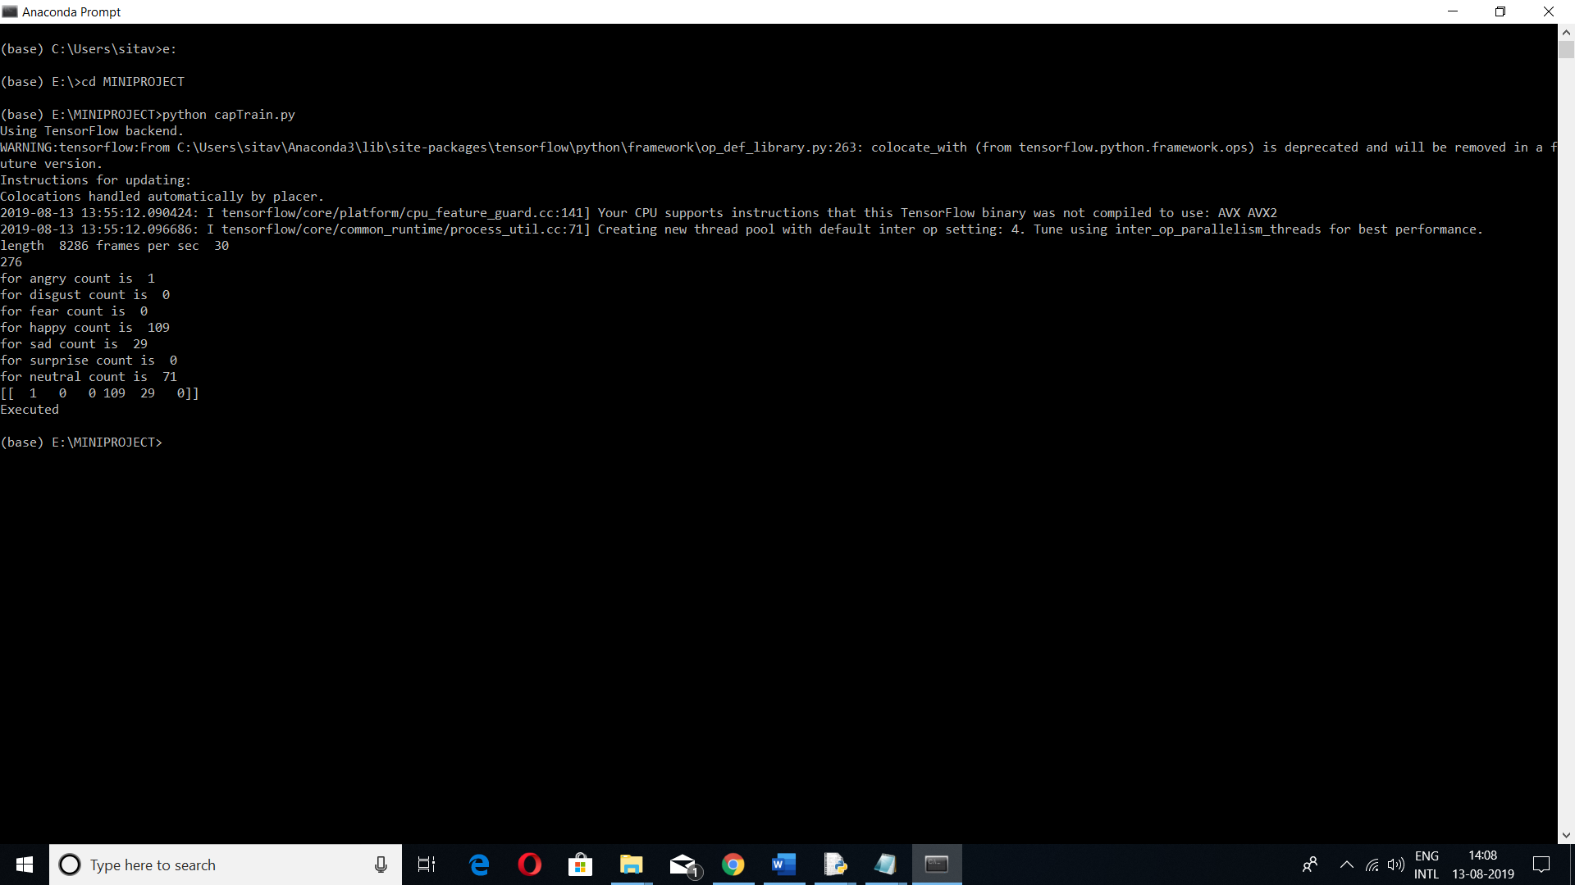

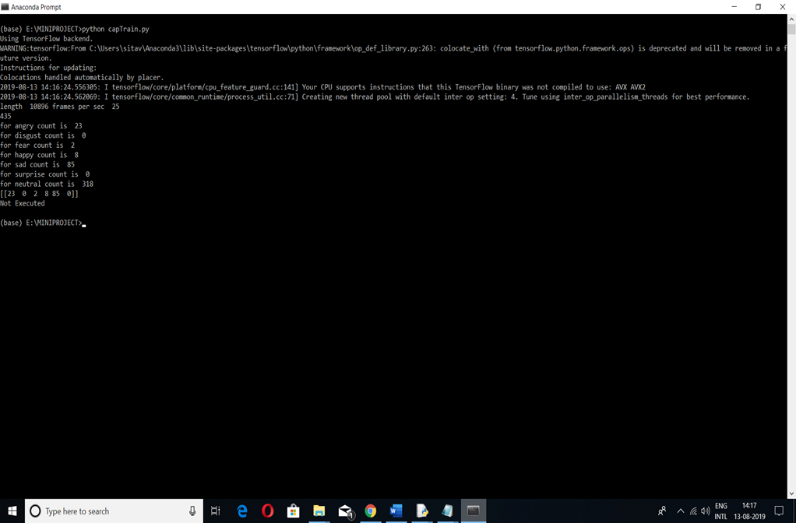
6.TESTING
6.1 INTRODUCTION:
Software Testing is a critical element of software quality assurance and represents the ultimate service of specification design and coding. The increasing visibility of software as a system element and the attended costs associated with the software failure and motivating forces for well planned, through testing. It is not unusual for a software development to spend between 30 to 40% of total project effort in testing. System Testing Strategies for this system integrate test case design techniques into a well-planned series of steps that result in the successful construction of this software. It also provides a road map for the developer, the quality assurance organization and the customer, a roadmap that describes the steps to be conducted as path of testing, when these steps are planned and then undertaken and how much effort, time and resources will be required. The test provisions are follows.

6.2 TESTING OBJECTIVES
The following are the testing objectives
- Testing is a process of executing a program with the intent of finding an error.
- A good test case is one that has a high probability of finding an as yet undiscovered error.
- A successful test is one that uncovers as a yet undiscovered error.

The above objectives imply a dramatic change in view point. They move counter to the commonly held view that a successful test is one in which no errors are found. Our objective is to design tests that systematically different clauses of errors and do so with minimum amount of time and effort. If testing is conducted successfully, it will uncover errors in the software. As a secondary benefit, testing demonstrates that software functions appear to be working according to specification and that performance requirements appear to have been met. In addition, data collected as testing is conducted provides a good indication of software. Testing can’t show the absence of defects, it can only show that software errors are present. It is important to keep this stated in mind as testing is being conducted.

6.3 TESTING PRINCIPLES
Before applying methods to design effective test cases, a software engineer must understand the basic principles that guide software testing.
- All tests should be traceable to customer requirements.
- Tests should be planned before testing begins.
- Testing should begin “in the small” and progress towards testing “in the large”.
- Exhaustive testing is not possible.

6.4 TYPES OF TESTING:
- Unit testing
- Integration testing
- Regression testing
- System testing
- Performance Testing
- Alpha testing
- Beta testing
Testing can be done manually or by testing tools .There are several testing tools for
different software.

Unit Testing: It is a method by which individual units of source code, sets of one or more
computer modules together with associated control data, usage procedures and operating
procedures, are tested to determine if they are fit for use. Unit testing focuses verification
effort on the smallest unit of software design-the software component or module. The unit test
is white-box oriented. The unit testing is implemented in every module of student attendance
management system. By giving correct manual input to the system ,the data is stored in
database and retrieved. If we want required module to access input or get the output , it
should be checked for the accessibility and result is to be displayed else error message
should be displayed.

Integration Testing: It is the phase in software testing in which individual software modules are combined and tested as a group. Integration testing takes as its input modules that have been unit tested, groups them in larger aggregates, applies tests defined in an integration test plan to those aggregates, and delivers as its output the integrated system ready for system testing.

Regression Testing: Regression testing is any type of software testing that seeks to uncover new software bugs, or regressions, in existing functional and non-functional areas of a system after changes such as enhancements, patches or configuration changes, have been made to them.

System Testing: System testing of software or hardware is testing conducted on a complete integrated system to evaluate the system’s compliance with its specified requirements.System testing is actually a series of different tests whose primary purpose is to fully exercise the computer-based system.

Performance Testing: Performance testing is designed to test the run-time performance of software within the context of an integrated system. Performance testing occurs throughout all steps in the testing process. Even at the unit level, the performance of an individual module may be assessed as white-box tests are conducted.This project reduces manual work and helps in getting students attendance status in much faster. No extra time is required waiting for the results, as soon as the correct data is entered the resulted will be displayed in a few millisecond.

Alpha Testing: Alpha testing is simulated or actual operational testing by potential users/customers or an independent test team at the developer’s site. Alpha testing is often employed for off-the-shelf software as a form of internal acceptance testing , before the software goes to beta testing.

Beta testing: Beta testing comes after alpha testing and can be considered a form of external user acceptance testing. Versions of the software, known as beta versions, are released to a limited outside of the programming team. The software is released to groups of people so that further testing can ensure the product has few faults or bugs. Sometimes beta versions are made available to the open public to increase the feedback field to a maximal number of future users.

Each module can be tested using the following two strategies:
(1) Internal program logic is exercised using ―White box ‖ test case design
Techniques.
(2) Software requirements are exercised using ―block box ‖ test case Design techniques. In both cases, the intent is to find the maximum number of errors with the Minimum amount of effort and time.

Black box Testing: In this strategy some test cases are generated as input conditions that execute all functional requirements for the program. This testing is used to find errors in the following categories:
- Incorrect or missing functions
- Interface errors
- Errors in data structure or external database access
- Performance errors
- Initialization and termination errors
In this testing , only the output is checked for correctness. The logical flow of the data is not checked.

White box Testing: In this testing, test cases are generated on the logic of each module by drawing flow graphs of that module and logical decisions are tested on all the cases. It is a method of testing software tests internal structures or workings of an application as opposed to its functionality( ie. Black box testing). In white box testing an internal perspective of the system, as well as programming skills, are used to design test cases. The tester chooses inputs to exercise paths throw the code and determine appropriate outputs. This is analogous to testing nodes in a circuit.
White box Testing can be applied at the unit, integration, system levels of the software testing process. Although traditional testers tened to think of White box Testing as being one at the unit level.

7.CONCLUSION

ASSESSING THE PERFORMANCE OF STUDENT BY EMOTIONS USING MACHINE LEARNING AND DEEP LEARNING TECHNIQUES is trained successfully using python with an accuracy of 86% against custom data set.
This can further be applied to various real-time image classification problems in engineering colleges for predicting behaviour of students while solving coding problems.In the case of tools for recognizing emotions on the basis of facial expressions,attention should be paid to the appearance of the object.Other objects may also be captured in the video,so for that purpose,harcascading came into play.This framework has the potential to be a practical tool for evaluating and positioning the culture of engineering education in the context of solving coding problems. Once the model gets trained successfully, a lot of human work in classifying images based on scans can be reduced to minimum.
This model summarizes the successful patterns of a student by avoiding the pitfalls of average student patterns to develop an innovative analysis tool and promotes to develop the best education.

8.BIBLIOGRAPHY
References:
- C.Agarwal, “Neural Networks and Deep learning”,1st edition,2018.
- F.Chollet, “Deep learning with python”, 1st edition,2017 Web References:
- http://deeplearning.net/tutorial/
- https://www.guru99.com/deep-learning-tutorial.html
- https://www.youtube.com/watch?v=Jy9-aGMB_TE Anaconda navigator download link
https://anaconda.org/anaconda/anaconda-navigator/1.9.6/download/win-64/anacondanavigator-1.9.6-py36_0.tar.bz2 Keras Documentation https://keras.io/ Python Download link
https://www.python.org/downloads/

